PRESS RELEASE
BLOOM BRITANNIA, a people’s opera
St. Mary in the Castle, Hastings
Friday 22nd October and Saturday 23rd October 7.30PM
Sunday 24th October 4PM

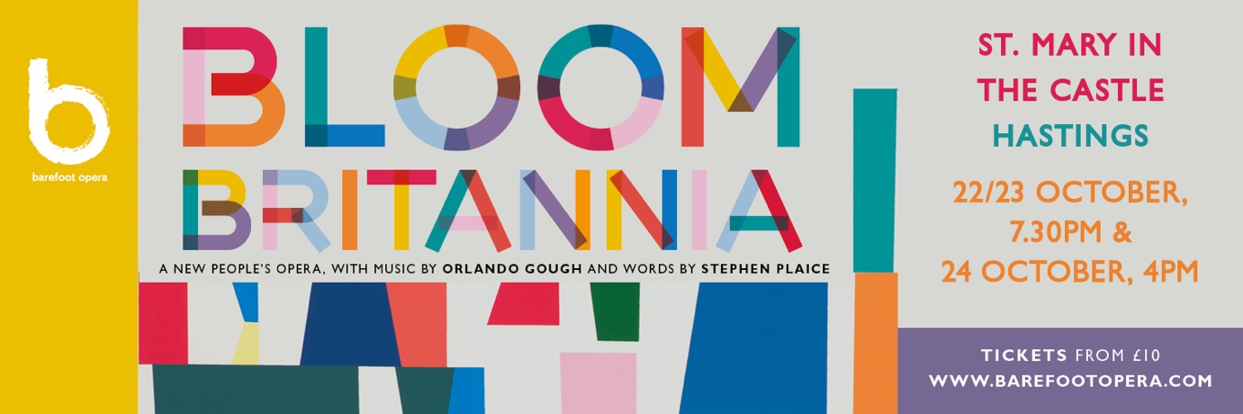

Telling the story of one extraordinary day in the life of a seaside town, Bloom Britannia – a new people’s opera - brings together a cast of people from the towns of Hastings, St. Leonards and Bexhill performing alongside top professional singers and a live band. Experience a hilarious, raucous, action-packed, thrilling production celebrating the joy of singing, music and creativity in bringing our communities together, and lifting our spirits.

Barefoot Opera’s new production BLOOM BRITANNIA is Barefoot Opera’s new, action-packed ‘people’s opera’, and it’s coming to St. Mary in the Castle in October for three performances. But what actually is a ‘people’s opera’? We caught up with some of the people taking part to find out…

‘The stories are relatable, the characters are relatable…there are lots of points of reference for anyone living in a seaside town’. (Julie Tucker-Williams, jewellery maker, mum of two, member of Shady Pines vocal group and Bloom Britannia participant)

BLOOM BRITANNIA has been made with - and for - people across the generations, and from all kinds of backgrounds. Many locals from Hastings, St. Leonards and Bexhill have been involved in this project since it got off the ground some years ago, and now they’ll be singing on the stage alongside a top professional cast, including St. Leonards local Peter Crouch, who says ‘It reflects a wonderful array of all the things that happen in a seaside town. I’m thrilled to be in it!’

A ‘people’s opera’ is also surely an opera with a story we can all relate to (and – unlike many operas - sung in English!) with characters we might recognise from our everyday lives, and BLOOM BRITANNIA promises not to disappoint. A ukulele-playing busker, a statue of Queen Victoria brought to life, a Hen Party, a choir of fishermen and a corrupt Mayor (nothing like our real Mayor of course!) are just some of characters. Bringing into focus the fun as well as some of the friction experienced by the residents of a fictional British seaside town as they compete in a national competition, it promises to be a story that will turn a few heads. Even Jack in the Green makes an appearance! ‘When I tell my friends I’m in an opera, they think it’s really weird with lots of funny ladies singing, but I tell them it’s just like a play, but with music. It’s cool!’ (Poppy Martin, Age 12, participant.)

An opera made in a music-loving town like Hastings was always going to have a certain musical flavour. Artistic Director Jenny Miller approached internationally known composer Orlando Gough – whose musical style brings together influences from pop, jazz and world music - to write the music for BLOOM BRITANNIA. She felt his approach would really suit a music project based in Hastings, a town with such a rich musical culture. ‘At the same time, he can write a tune that stays in your head’ she says. This is an opera not with an orchestra, but with a live band – including many musicians based locally, including Tom Clarkson, and multi-instrumentalist and singer, Hastings born and bred Bev Lee Harling, and even the odd spot of beat-boxing.

‘It’s no holds barred…there’s an aria then some jazz then a drunken hen night! It’s a great big mix-up and it’s for everybody’ (Bev Lee Harling, singer and multi-instrumentalist)
A wide range of different organisations, community groups and choirs are also involved. Children from Dudley Infants School and Bexhill Academy, as well as pupils from Hastings Academy, will be on stage, as will singers from Hastings Philharmonic Choir, from local vocal group Now and Then, and performers from local theatre company Theatre Nation. The leading local arts group Project Art Works - an artist-led organisation working with children, young people and adults who have complex support needs, are working on the set design with artist Peter Fillingham. Barefoot Opera have also worked with The Seaview Project, Arts On Prescription and StageCoach in bringing free music education across the community.

‘I used to think opera was in a foreign language…and thought it was for toffs and the posh people, but having done some of the work with Barefoot Opera, its opened my mind to different genres of music’ (Paul Toon, Bloom Britannia workshop participant)

So why not give it a try… show your support for new music, and the many local people, organisations and musicians involved in BLOOM BRITANNIA. And after more than a year when we’ve all longed for social interaction, and recognised how much we need music and theatre, this really is a production not to miss!

TICKETS
Tickets, priced from £10-£25 (and with £5 tickets for children under 12) are now on sale for the three performances that will take place from 22-24 October at St. Mary-in-the Castle, Hastings, slap bang in the middle of the seafront - you could say, exactly where it belongs. You can buy tickets on the Barefoot Opera website or from Hastings Tourist Office.

Further info: www.barefootopera.com

