PRESS RELEASE
BLOOM BRITANNIA, a people’s opera
St. Mary in the Castle, Hastings

Friday 22nd October and Saturday 23rd October 7.30PM
Sunday 24th October 4PM

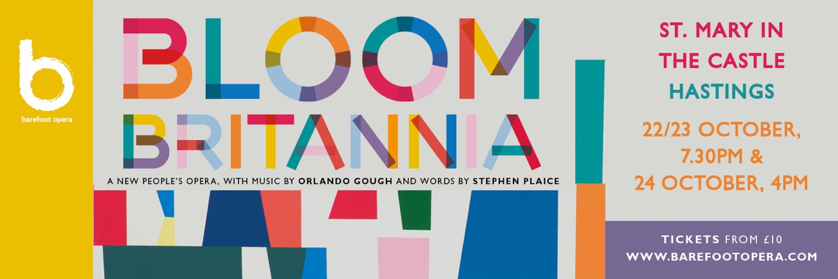

Barefoot Opera presents a new ‘people’s opera’ by leading composer Orlando Gough and librettist Stephen Plaice, a post-Brexit satire on the Great British seaside, sung by the people who live there. Coming to the stage in Hastings this Autumn, Bloom Britannia is a ‘state of the nation’, inclusive, contemporary production that tells the story of one extraordinary day in the life of a seaside town. An outstanding team of professionals will perform alongside a chorus of people from Hastings, St. Leonards and Bexhill, including award-winning soprano Abigail Kelly, ENO regular Simone Ibbett-Brown, leading director, Polly Graham, and conductor Christopher Stark.

‘A majestic opus combining the global with the local, the political with the social, the present and the historical, in a fabulous operatic romp. And the icing on the cake is that it will be performed by real people with real lives - guided, encouraged and led by professional artists
and hopefully watched by an equally diverse audience.’
Peter Crouch, member of the chorus, Bloom Britannia

A ukulele-playing busker, a statue of Queen Victoria brought to life, a Hen Party, a choir of Angry Fishermen and a corrupt Mayor are just some of characters that appear in Barefoot Opera’s new ‘people’s opera’ Bloom Britannia. Its focus is the hilarity and discord experienced by the residents of a fictional British seaside town – not unlike Hastings - as they compete for a national regeneration award, a subject that promises to be as familiar as it is engaging.
Barefoot Opera, an organisation which seeks to invert opera’s somewhat elitist profile and become more inclusive, is based in Hastings on the Sussex coast, and aims to attract amateurs as well as professionals in both educational and performative roles. Educational outreach, supported by the Arts Council and a number of other funding bodies, has provided free teaching and workshops for schools, charities and community groups for the last few years. Many of these participants will be performing in Bloom Britannia alongside the professional cast.
Barefoot Opera’s Artistic Director Jenny Miller approached Orlando Gough to develop the opera owing to his mastery in blending pop, jazz and world music with contemporary classical music, something she felt would suit an opera based in Hastings, a town with a rich and diverse musical heritage. ‘At the same time, he can write a tune that stays in your head’ she says. Librettist Stephen Plaice brings his wit and flexibility to the project, whilst award-winning director Polly Graham, already making headlines as Artistic Director of Longborough, and who Miller describes as a ‘natural’ in working with an inclusive community group, brings a youthful energy and dynamism to the production. And with Christopher Stark, Principal Conductor of the Multi-Story Orchestra, conducting, Miller assures that audiences can expect a production that has flair, intelligence and humour in equal measure.

The outcome of several years of development – and having been thrown off course by the pandemic – the opera began life in 2018 when hundreds of people from the towns of Hastings, St. Leonards-on-Sea and Bexhill took part in singing and discussion workshops, learning how to write songs, improvise, and sing together.

The professional cast includes singers and musicians based locally to East Sussex, for example Chiara Vinci, Bev Lee Harling and Marcia Bellamy, as well as several from further afield, including Abigail Kelly and Simone Ibbett-Brown, one of BBC Radio 3’s Next Generation Voices. Turner Prize 2021 nominees Project Art Works are working on set design under the creative direction of artist Peter Fillingham.

Tickets, priced from £10-£25 are now on sale for the three performances that will take place from 22-24 October at St. Mary-in-the Castle, Hastings, an iconic former Georgian church and now arts and performance space, which sits in a suitably commanding position on Hastings seafront and is built into the rocks under Hastings Castle. BOOK HERE
Further enquiries please contact Janet Hodgson on 07968 778356 or via janet.barefootopera@gmail.com
www.barefootopera.com

Notes for editors:

PROFESSIONAL CAST

Mayor | Nick Morris
Pauline | Alice Privett
Cassie | Marcia Bellamy
Queen Vic | Chiara Vinci
Serge | Laurence Panter
Ellie | Abigail Kelly
Mervyn | Laurence Panter
Nusha | Chiara Vinci
Dustin | Gwion Thomas
Jackie | Simone Ibbett-Brown
Wally | Gwion Thomas
Apple Jonny | Patrick Kealey
Street Sweeper | Jenny Miller
Busker | Bev Lee Harling
TBC | Lekiddo
Street Sweeper | Jenny Miller
Hen - Bella | Simone Ibbett-Brown

The Barefoot Band
Piano: Lesley Anne Sammons
Percussion: Derek Scurll
Trombone: Patrick Kenny
Guitar: Tom Clarkson
Double Bass: Lucy Mulgan
Violin: Ruby Colley
Violin: Bev Lee Harling
Clarinet: George Sleightholme
Accordion: Aine Mcloughlin

Production Team
Assistant Director: Callie Nestleroth
Lighting designer: Ace McCarron
Costume designer: April Dalton
Set designer: Peter Fillingham, working with Project Art Works
Production Manager: Jon Tyrrell
Stage Manager: Zo Morgan
DEVELOPED WITH FUNDING FROM THE ARTS COUNCIL OF ENGLAND, BATLEY HIBBERT TRUST, THE MAGDALEN AND LASHER CHARITY, SUSSEX COMMUNITY FOUNDATION, HASTINGS BOROUGH COUNCIL AND THE GOOD GOVERNANCE INSTITUTE

