PRESS RELEASE
BLOOM BRITANNIA, a people’s opera
St. Mary in the Castle, Hastings

Friday 22nd October and Saturday 23rd October 7.30PM
Sunday 24th October 4PM

Tickets from £10 from www.barefootopera.com

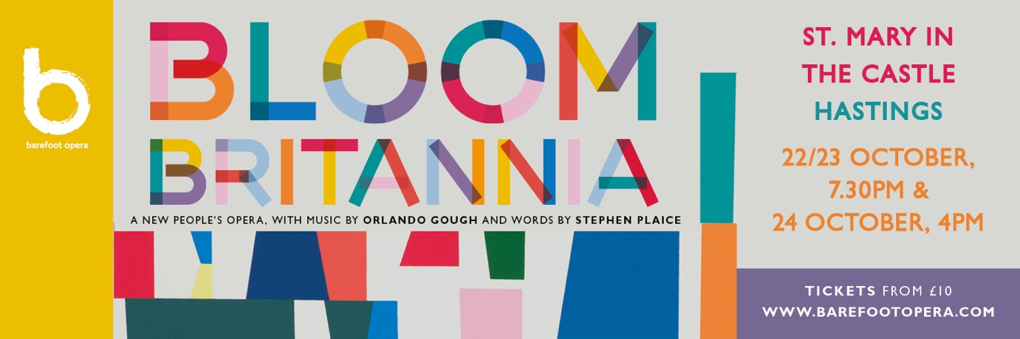

Premiere of the new people’s opera Bloom Britannia to take place in Hastings this Autumn. Telling the story of one extraordinary day in the life of a seaside town, Bloom Britannia brings together a cast of people from the towns of Hastings, St. Leonards and Bexhill performing on stage alongside top professional singers and a live band. Experience a hilarious, raucous, challenging, action-packed, thrilling production celebrating the joy of singing and music to bring our communities together.

A ukulele-playing busker, a statue of Queen Victoria brought to life, a Hen Party, a choir of Angry Fishermen and a corrupt Mayor are just some of characters that appear in Barefoot Opera’s new ‘people’s opera’ Bloom Britannia. Bringing to life the fun as well as some of the friction experienced by the residents of a fictional British seaside town as they compete in a national competition, it promises to be a story we can all relate to.
Barefoot Opera has provided provide free teaching and workshops for schools, charities and community group like the Seaview Project and Arts On Prescription for the last few years. Local schools Dudley Infants School and Hastings Academy are also involved, as is Hastings Philharmonic Choir. This is an opera, but not as you know it. Local people of all ages will be performing in Bloom Britannia alongside the professional cast and with the Barefoot Band, including ukulele, violin and accordion and even the odd spot of beat-boxing.
The outcome of several years of development, the opera began life in 2018 when hundreds of people from the towns of Hastings, St. Leonards-on-Sea and Bexhill took part in singing and talking workshops, learning how to write songs, improvise, and sing together, led by a leading creative team. A huge momentum was generated by the project after a thrilling interim performance of Act 1 of the opera at the De La Warr Pavilion in 2019. Then the project was then thrown off course for a year by the pandemic – a huge disappointment for Barefoot Opera and the entire cast.

But thanks to funding from Arts Council of England, many other funding bodies and the Good Governance Institute, rehearsals have again been in full swing since Easter with a stalwart chorus of committed participants who have faithfully pursued learning the music throughout the ever-changing minefields of Covid restrictions, determined to keep the show on the road. Barefoot Opera Artistic Director Jenny Miller has been thrilled that so many people have been involved with the project since the outset, including young people like Justin Greenland and Bexhill College student Poppy Martin. ‘The commitment they have shown speaks volumes for the music, and the rich rewards of taking part in a professional production’, she says.

Hastings local Peter Crouch, who sings in the chorus as a fisherman, describes Bloom Britannia as ‘a fabulous operatic romp!’ And the icing on the cake, he says, is that ‘it will be performed by real people with real lives guided, encouraged and led by professional artists and hopefully watched by a really mixed audience’.

Miller approached composer Orlando Gough to develop the opera owing to his reputation for bringing together influences from pop, jazz and world music, something she felt would really suit a music project based in Hastings, which as we know is a town with a rich and diverse musical heritage. ‘At the same time, he can write a tune that stays in your head’ she says. Librettist Stephen Plaice brings his wit and flexibility to the project, (he describes the opera as ‘Carmen, with Lobsters’) whilst award-winning director Polly Graham, who Miller describes as a ‘natural’ in working with community groups and people of all ages, brings a youthful energy and dynamism to the production. And with Christopher Stark, Principal Conductor of the Multi-Story Orchestra, conducting, Miller assures that audiences can expect a production that has flair, intelligence and humour in equal measure.

The professional cast includes singers and musicians based locally to East Sussex, including long-term Barefoot collaborators Chiara Vinci, Bev Lee Harling and Tom Clarkson, as well as several award-winning singers from further afield and Glastonbury favourite Lekiddo.

Tickets, priced from a very affordable £10-£25 are now on sale for the three performances that will take place from 22-24 October at St. Mary-in-the Castle, Hastings, slap bang in the middle of the seafront - you could say, exactly where it belongs. You can buy tickets on the Barefoot Opera website or from Hastings Tourist Office. BOOK HERE

Wish you were in it? There’s still time to take part!
Whilst it has taken a lot of commitment and focus to follow this project through entirely, Jenny Miller wants to let people know that there are still opportunities to take part in a more low-key way, meaning they can have the amazing experience of being in a once in a lifetime show, without bending a busy schedule drastically out of shape. You only need to contact bloom@barefootopera.com to find out more.
Further enquiries please contact Janet Hodgson on 07968 778356 or via janet.barefootopera@gmail.com
www.barefootopera.com

